**Exercise 11: Online Bookstore – Integrating Spring Boot Actuator**

Business Scenario:

Monitor and manage your bookstore's RESTful services using Spring Boot Actuator.

1. **Add Actuator Dependency:**

* I included the Spring Boot Actuator dependency in my pom.xml file:

Actuator: Monitoring our app, gathering metrics, and understanding traffic or the state of our database becomes trivial with this dependency.

The Actuator mainly exposes operational information.

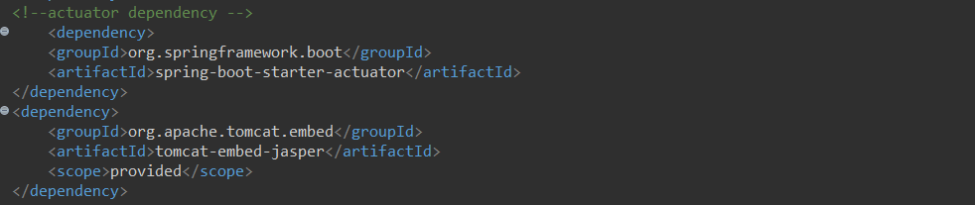

1. **Expose Actuator Endpoints:**

* I enabled and customized Actuator endpoints in Application.properties:

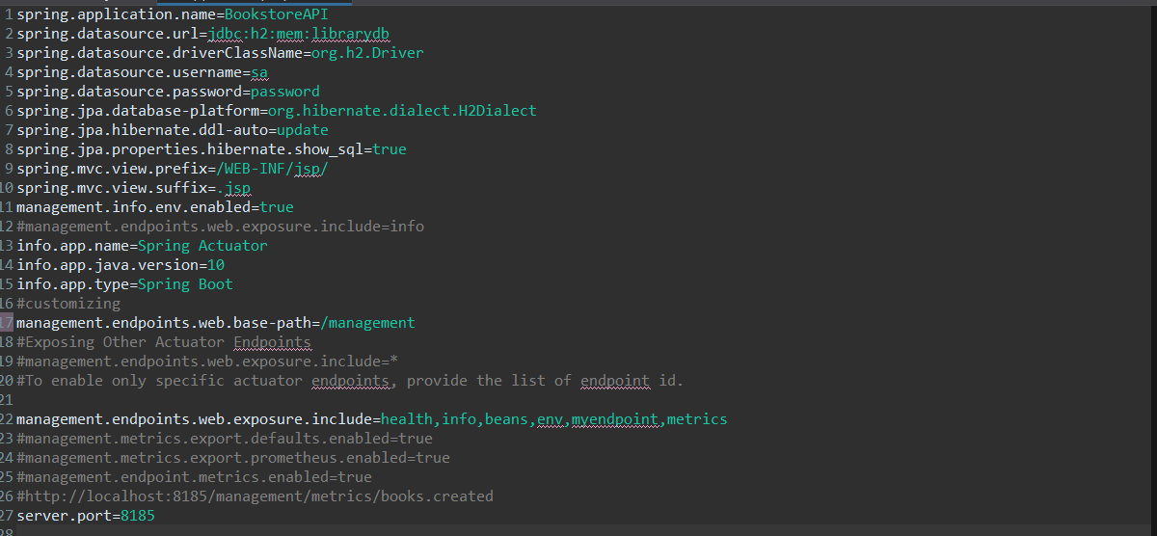

1. **Custom Metrics:**

* I exposed custom metrics for monitoring the application and is included in BookService class and also I created a class named MyCustomEndPoints:

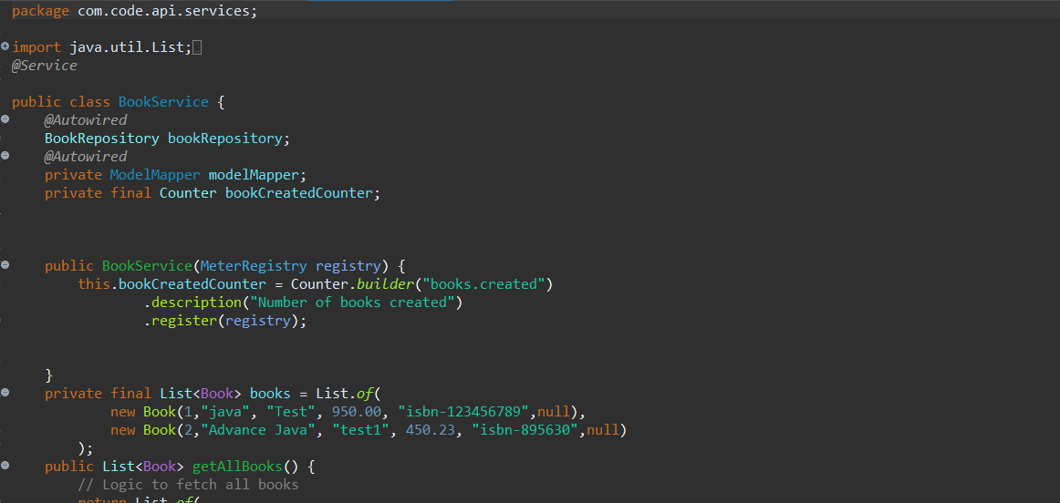

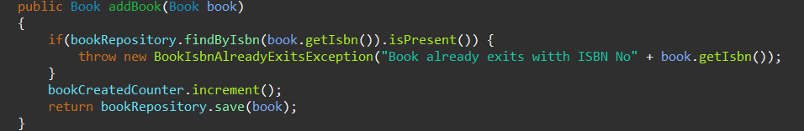

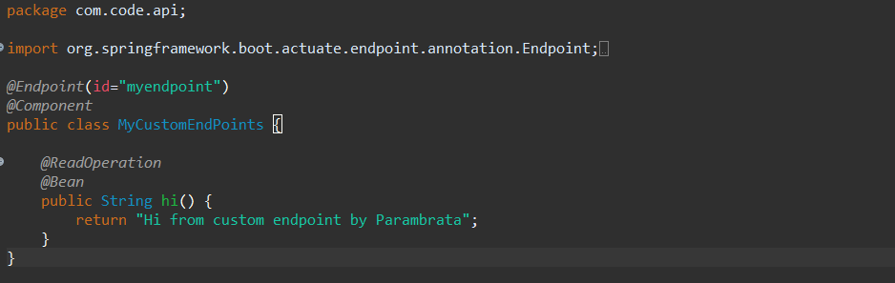

**Output:**

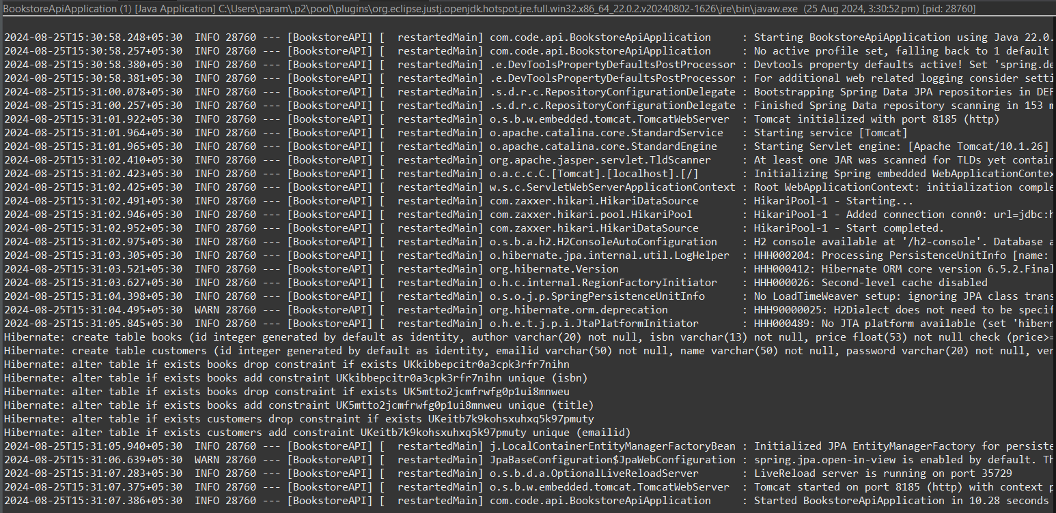

Metrics:

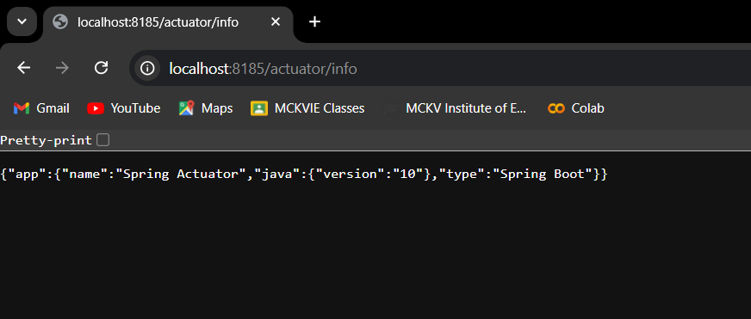

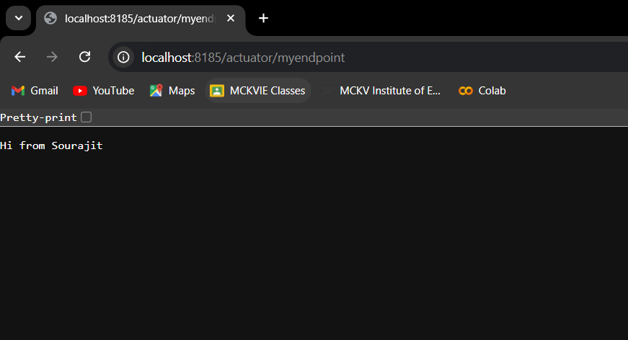

POST in Postman:

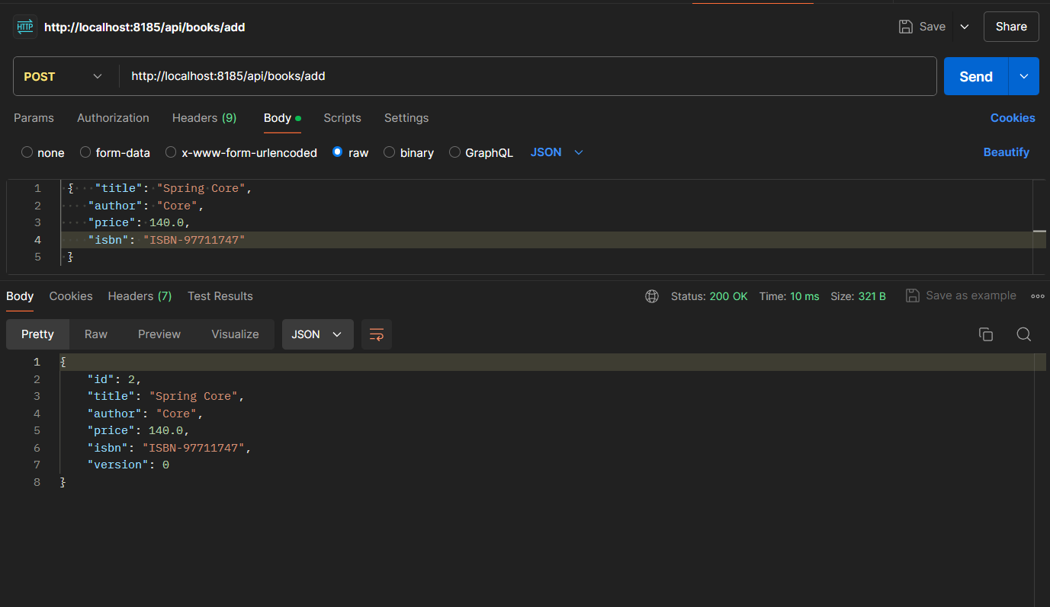

Books created is shown:

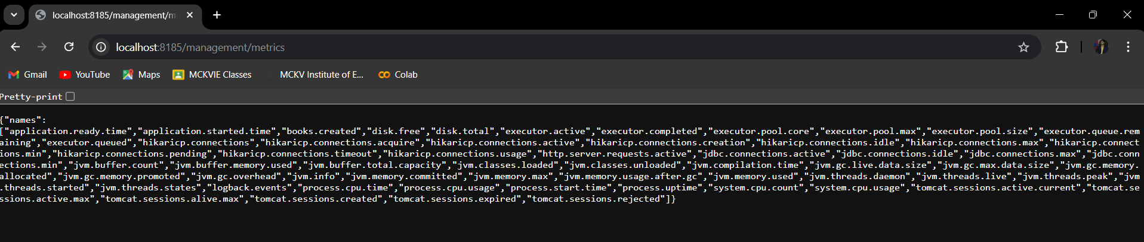

Counter 2 check:

